

Generator Battery Testing Procedure
Guideline for Starting Static Generators
Facilities Management
Terri Quigley
15/12/2020

Document No: | GEN001
Title:  Revision:  Date: | Generator Battery Testing Procedure  Rev.001  15/12/20
 | NAME | TITLE | SIGNATURE | DATE
Technical Approver | Kieran Delaney | Regional Facilities Manager
FM Department Approver | Terri Quigley | Head of Facilities & Energy
Director Approval | Allan Rochford | Director

This document details how to test static generator batteries prior to starting the generator and during the generator running

Contents
How-to: Testing Generator Batteries 2
Generator in situ 2
Initial set up before starting the generator: 2
Operation for a 12 Volt Battery 5
Operation for a 24 Volt Battery 6
Taking Readings 6
Example Reading Before Starting Generator 6
Selecting Min/Max from Fluke 113 Meter Prior to starting the Generator 7
Start Generator 7
Fluke 113 Digital Multimeter 9
Quick Guide: 9
Fluke Manual and Data Sheet Details 11

How-to: Testing Generator Batteries

Generator in situ

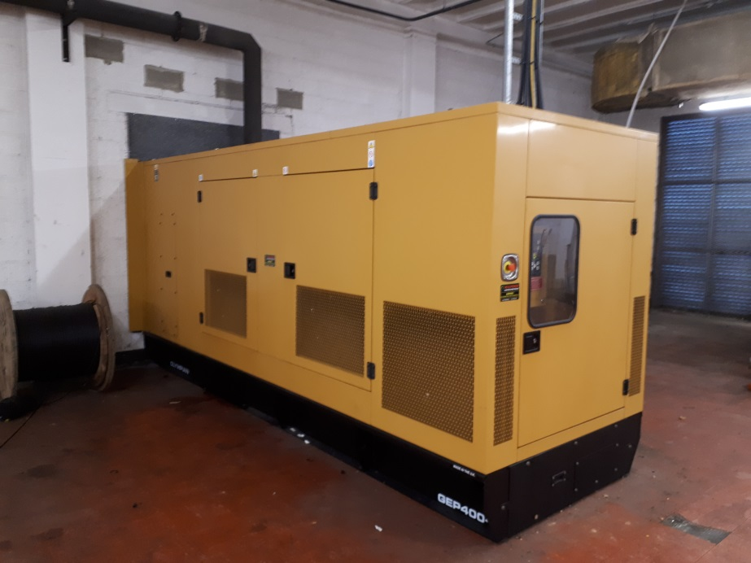

Initial set up before starting the generator:

Step 1: Locate the Starter connected to the batteries

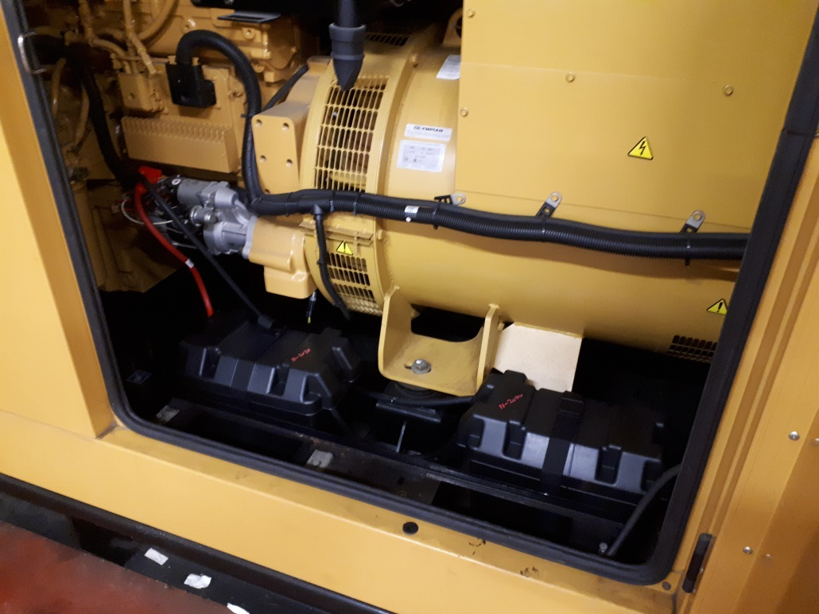

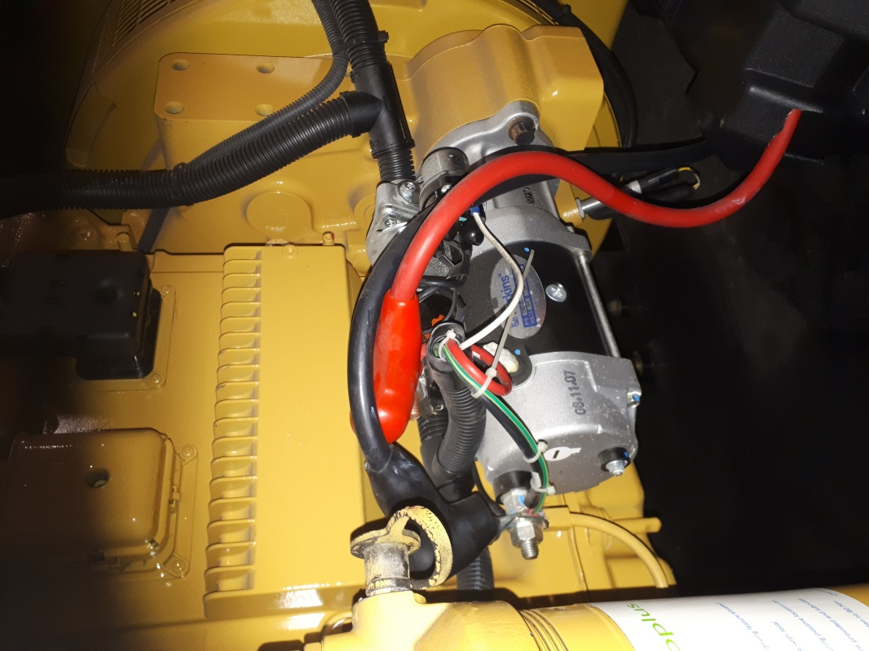

Step 2: Connect the red lead clamp from your meter to the positive connection on the starter as shown below
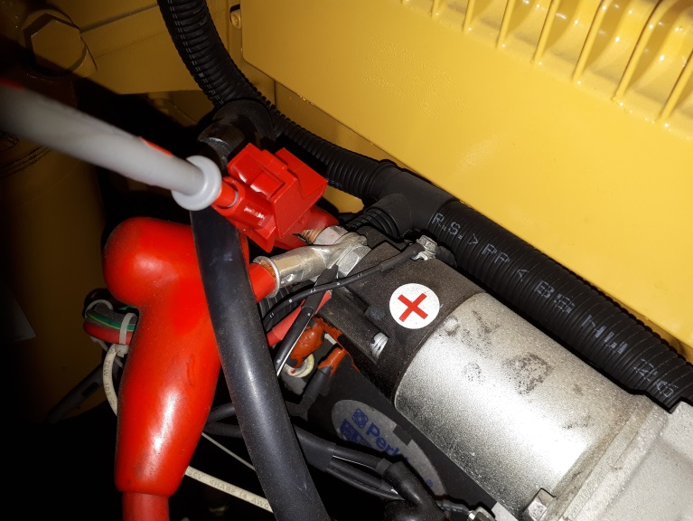

Step 3: Connect the black lead clamp from your meter to the negative connection on the starter as shown below

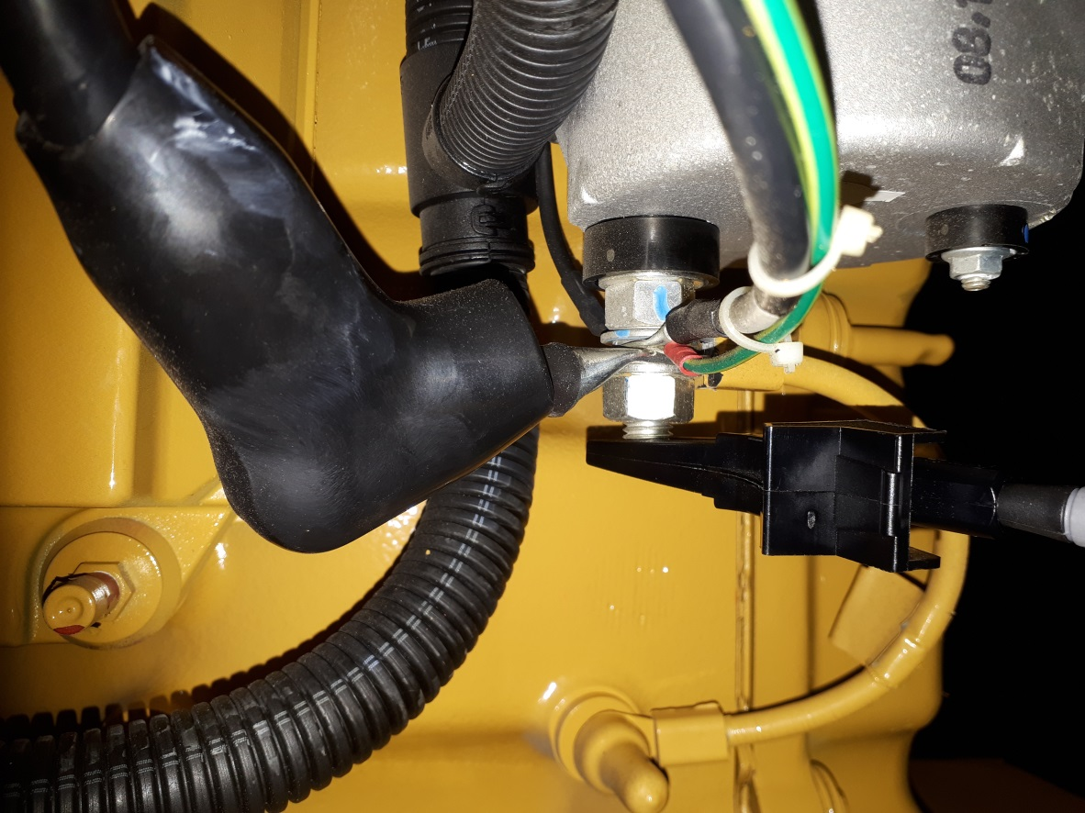

Operation for a 12 Volt Battery
12 Volt Starter Batteries
- On a 12V system the static charger will normally have an average reading before any starting operation is carried out of between 13.20V up to a maximum of 13.80V.
- If the reading is 14.0 volts or under it is ok to start the generator
- If the static battery charging voltage exceeds 14.0 volts do not proceed with generator routine and log a request for immediate attention with Facilities Helpdesk @ 1800 701 434. DO NOT START THE GENERATOR.
- Reading of under 12.5 volts may indicate a faulty charger and should be logged to Facilities Helpdesk for check. DO NOT START THE GENERATOR.
- Note that the engine driven battery charging regulator has a different profile that can provide a typical output voltage of 14.9V when the engine is running.

Operation for a 24 Volt Battery
24 Volt Starter Batteries
- On a 24V system the static charger will normally have an average reading before any starting operation is carried out of between 26.80 volts up to a maximum of 27.60 volts.
- If the reading is 27.8 volts or under it is ok to start the generator
- If the battery charging voltage exceeds 28.0 Volts do not proceed with generator routine and log a request for immediate attention with Facilities Helpdesk @ 1800 701 434. DO NOT START THE GENERATOR.

- Voltage reading of under 25.5 volts may indicate a faulty charger and should be logged to Facilities Helpdesk for check. DO NOT START THE GENERATOR.
- Note that the engine driven battery charging regulator has a different profile that can provide a typical output voltage of 28.80V when the engine is running.

Taking Readings

Example Reading Before Starting Generator
The following is a normal charging voltage before starting the generator, called the static voltage (this example is for a 24 Volt Battery):
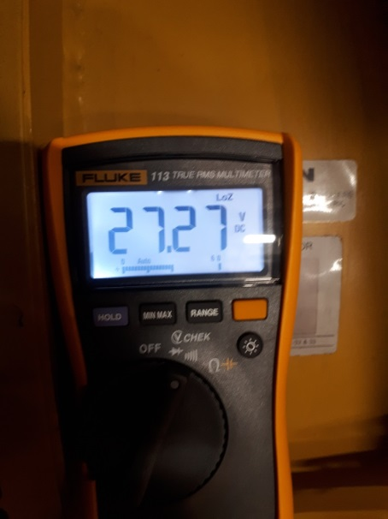

Selecting Min/Max from Fluke 113 Meter Prior to starting the Generator
Once the charging voltage has been taken press and is within range press the Min/Max button to record the minimum and maximum voltages. The meter should beep once to confirm that you have selected min/max mode:
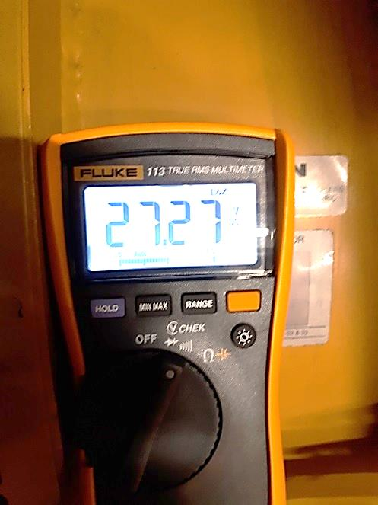

Start Generator
Once selected you can now start the generator from the secondary switch location and let the generator run 1-2 minutes to take accurate readings.
Your first reading after starting the generator should show the Max voltage, known as engine max output charging as shown in example below, you must press the min/max button once to get this reading:

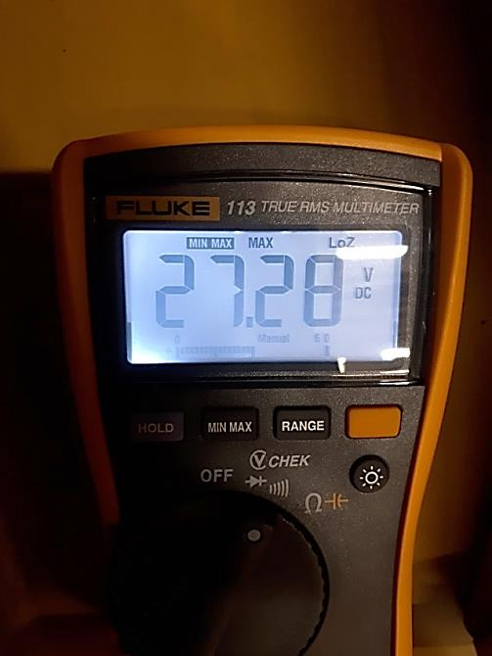

You then press the Min/Max button again to get the minimum voltage, known as the crank dip voltage:
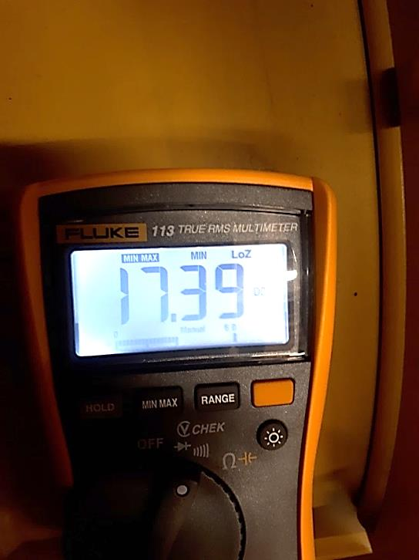

You press the Min/Max button again to get the average voltage:

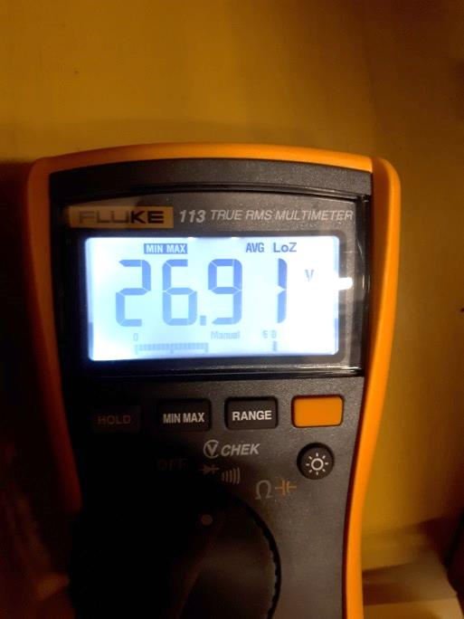

You should then record the readings for inclusion to the RTD database:

Type of Reading | Reading recorded
Static Voltage (Charging Voltage)
Max Voltage (Engine Max Output)
Min Voltage (Crank Dip Voltage)
Average Voltage

Fluke 113 Digital Multimeter

Quick Guide:

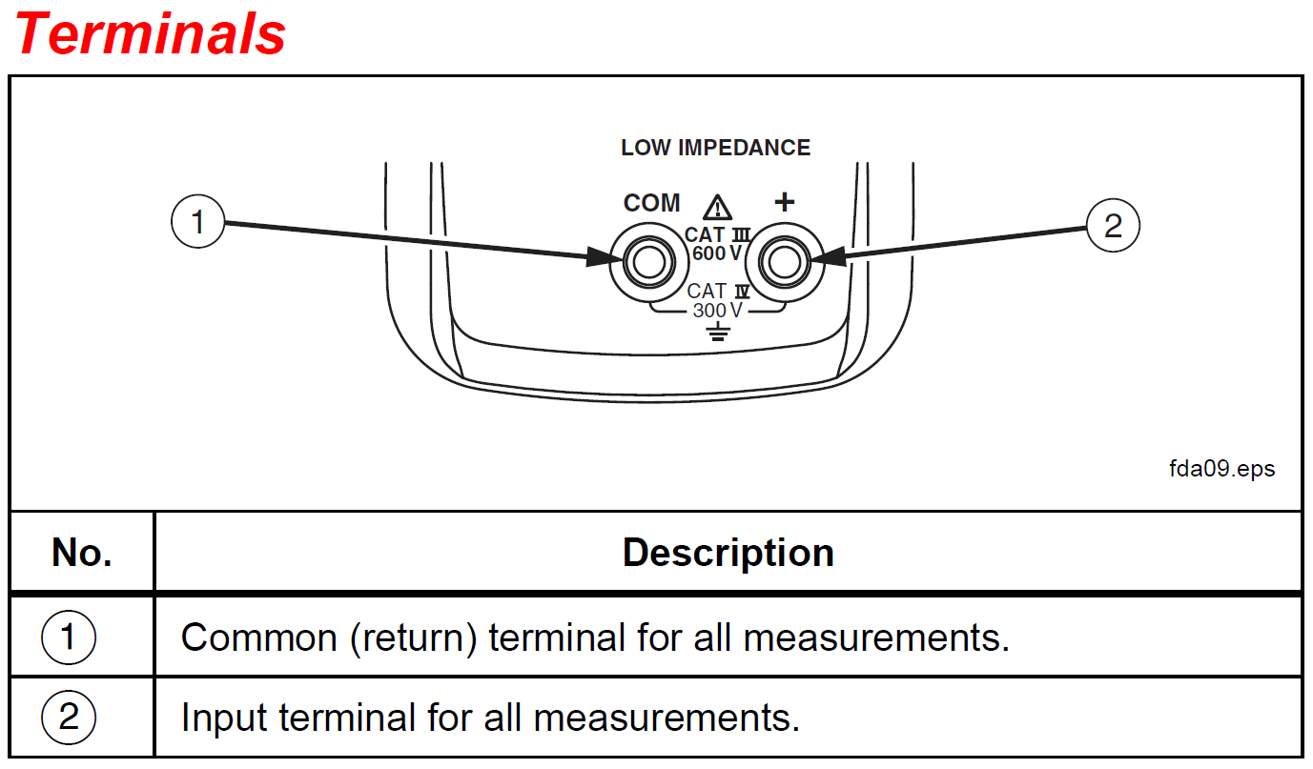
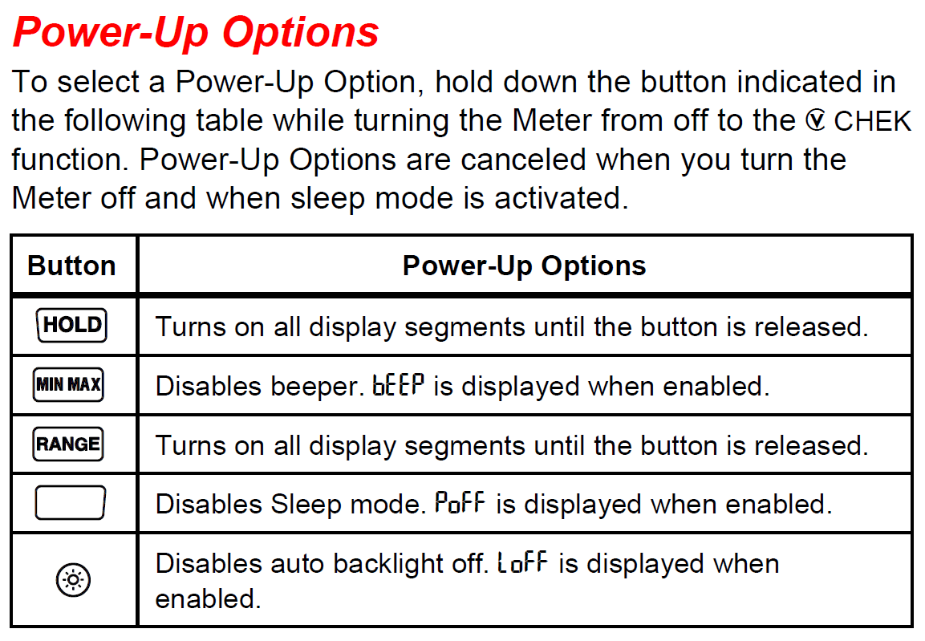
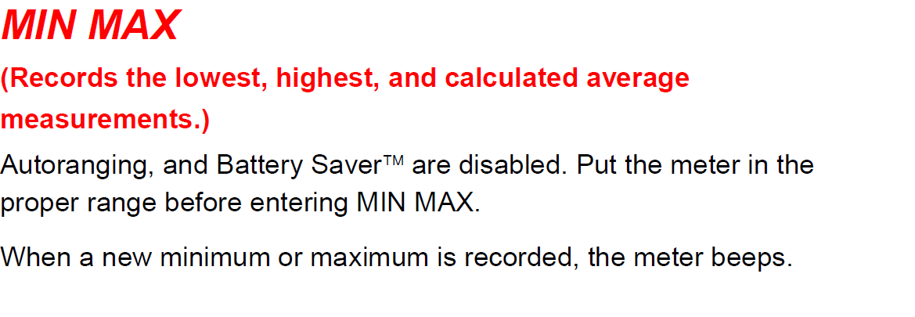

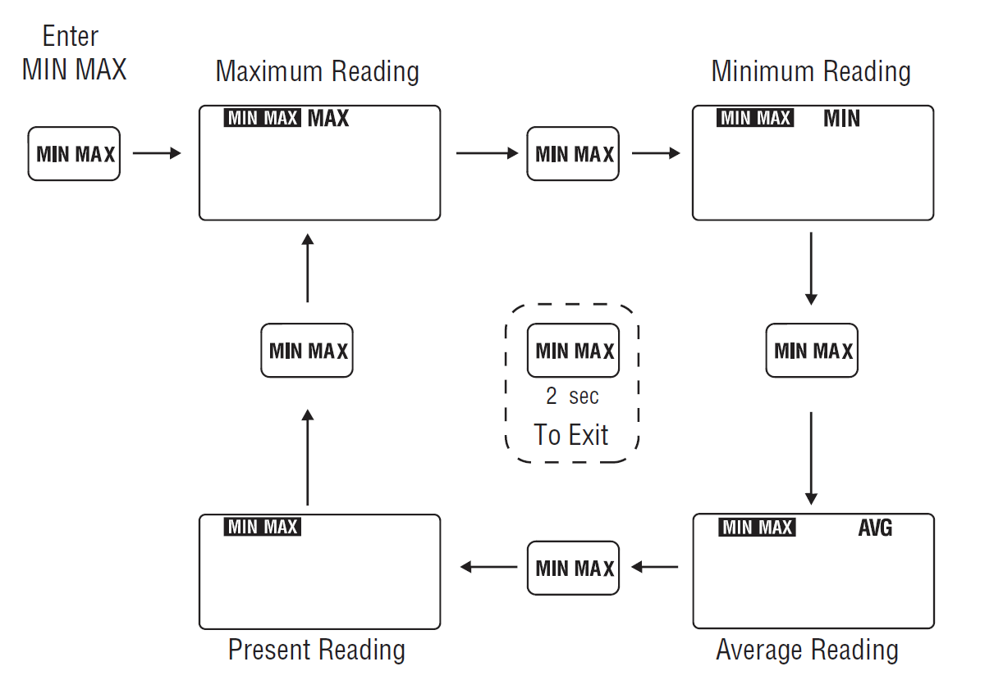

Fluke Manual and Data Sheet Details

Full details of Fluke 113 Digital Multimeter including manual and data sheet can be found at: https://www.fluke.com/en-gb/product/electrical-testing/digital-multimeters/fluke-113

